Project Design Phase-II Technology Stack (Architecture & Stack)

|  |  |
| --- | --- |
| Date | 26 October 2022 |
| Team ID | PNT2022TMID45702 |
| Project Name | AI based localization and classification for skin disease with erythema |
| Maximum Marks | 4 Marks |

# Technical Architecture:

The Deliverable shall include the architectural diagram as below and the information as per the table1 & table 2

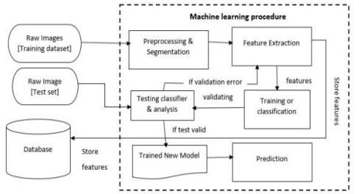

# Table-1 : Components & Technologies:

|  |  |  |  |
| --- | --- | --- | --- |
| **S.No** | **Component** | **Description** | **Technology** |
| 1. | User Interface | The user can interact with informative webUI.Additionally a chatbot for basic assistance  on how to use the portal will be present. | Python flask |
| 2. | Application Logic-1 | Authentication | JavaScript / Python |
| 3. | Application Logic-2 | chatbot | Python Rasa |
| 4. | Application Logic-3 | ML Algorithm | Python,Tensorflow |
| 5. | Database | Data Type, Configurations etc. | MySQL, /MongoDB |
| 6. | Cloud Database | Database Service on Cloud | IBM Cloudant |
| 7. | File Storage | File storage requirements | Local Filesystem |
| 8. | External API-1 | logging in by many ways | Gmail login , Facebook login API |
| 9. | Machine Learning Model | Skin disease detection | ML model(yolo) |
| 10. | Infrastructure (Server / Cloud) | Application Deployment on Cloud | Versel/Netlify |

**Table-2: Application Characteristics:**

|  |  |  |  |
| --- | --- | --- | --- |
| **S.No** | **Characteristics** | **Description** | **Technology** |
| 1. | Open-Source Frameworks | List the open-source frameworks used | Tensorflow |
| 2. | Security Implementations | List all the security / access controls implemented, use of firewalls etc. | web authn |
| 3. | Scalable Architecture | Justify the scalability of architecture (3 – tier, Micro-services) | Kubernetes |
| 4. | Availability | Traefik is a web server that can be used for load balancing etc, | Traefik, Docker |
| 5. | Performance | Request and response time delay, number of request, system/tech crashes | postman, sentry.io |